|  |
| --- |
| PS2Win |
| Weekly Report |
| Keep Your Time |

|  |
| --- |
| Carla Machado  09-03-2013 |

**Team Members:**

Carla Machado

David João

Filipe Brandão

João Girão

João Martins

Mário Oliveira

Rui Ganhoto

**Week 3**, 4th of March to 11th of March

Content

1. Week Activities 1

1.1. Work Executed 1

1.2. Achievements 1

2. Impediments 1

3. Plans For Next Week 1

4. Progress 2

4.1. Earned value and/or Gantt Image 2

4.2. Effort by task 2

4.3. Individual effort 3

5. Individual log 3

**Images**

Figure 1 - Earned Value 2

Figure 2 - Effort by task type 2

Figure 3 - Effort by team member 3

**Tables**

Table 1: List of Contributors ii

Table 2: Version history ii

Table 3: Log of individual effort 3

|  |  |  |  |
| --- | --- | --- | --- |
| **Authors and Contributors** | | | |
| **Date** | **Name** | **Contacts** | **Contribution** |
| 09-03-2013 | Carla Machado | a21170460@alunos.isec.pt | Author |
| 09-03-2013 | Filipe Brandão | a21180276@alunos.isec.pt | Author |
| 11-03-2013 | Mário Oliveira | a21170292@alunos.isec.pt | Contributor |
| 11-03-2013 | Rui Ganhoto | a21170262@alunos.isec.pt | Contributor |
| 11-03-2013 | João Martins | a21170228@alunos.isec.pt | Contributor |
|  |  |  |  |
|  |  |  |  |
|  |  |  |  |
|  |  |  |  |

Table 1: List of Contributors

|  |  |  |  |  |  |
| --- | --- | --- | --- | --- | --- |
| **Revision History** | | | | | |
| **Date** | **Description** | **Author** | **Version** | **Approvers** | **State** |
| 09-03-2013 | Creation of first draft | Carla Machado | 0.1 |  | Draft |
| 10-03-2013 | Added graphs and minor updates | Filipe Brandão | 0.2 |  | Ready for Revision |
| 11-03-2013 | Document reviewed | Mário Oliveira | 0.2 |  | Ready for Revision |
| 11-03-2013 | Small changes as result of the review.  Document ready for approval | Carla Machado | 0.3 |  | Ready for Approval |
| 11-03-2013 | Approval |  | 0.3 | Rui Ganhoto | Ready for Approval |
| 11-03-2013 | Approval |  | 0.3 | João Martins | Ready for Approval |
| 11-03-2013 | Baselined | Filipe Brandão | 1.0 |  | Baselined |
|  |  |  |  |  |  |

Table 2: Version history

# Week Activities

# Work Executed

* Improving Vision & Scope Document;
* Adding more information to the Dashboard;
* Review and approval of Document Management Process version 1.0;
* Update of Document Management Process to include a life cycle diagram;
* Beginning of processes definition (Project Planning, Requirements Analysis, Project Assessment and Control), update of estimates;
* Planning of next Progress Meeting.

# Achievements

No major achievement identified.

# Impediments

None identified.

# Plans For Next Week

* Get Requirements Analysis Process ready for review and baseline Project Planning Process.

# Progress

# Earned value and/or Gantt Image

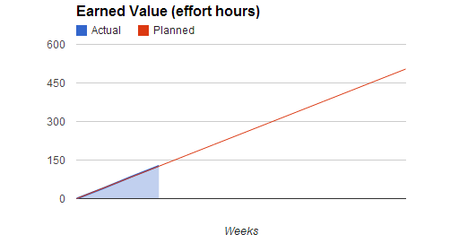

Figure 1 - Earned Value

Actual = 127.5 hours

Planned = 126 hours

# Effort by task

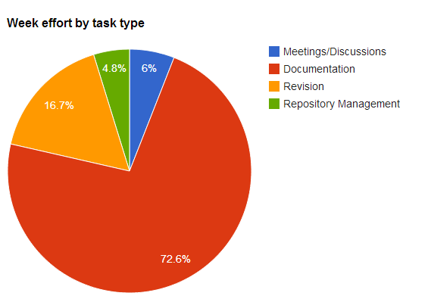

Figure 2 - Effort by task type

# Individual effort

(Graph and table with individual real effort)

|  |  |
| --- | --- |
| **Name** | **Effort(hours)** |
| Carla Machado | 6.5 |
| David João | 5.5 |
| Filipe Brandão | 5.5 |
| João Girão | 6 |
| João Martins | 6.5 |
| Mário Oliveira | 6 |
| Rui Ganhoto | 6 |

Table 3: Log of individual effort

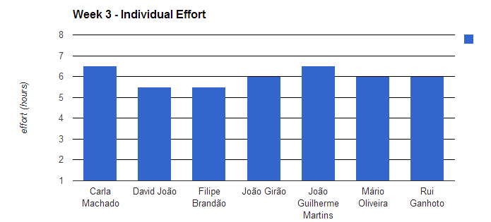

Figure 3 - Effort by team member

# Individual log

**Carla Machado - Tasks done:**

* Document Management Process;
* Planning processes;
* Requirements analysis process;
* Application of Document Management Process;
* Discussion about estimates, task Types and task assignments;
* Weekly Report.

**David João - Tasks done:**

* Teamwork discussion;
* Template Processes Review and Approval;
* First draft of Project Assessment and Control Process;
* Document Management Process Reading and Approval.

**Filipe Brandão - Tasks done:**

* Reviewing documents management process and Vision and Scope. Approving Templates;
* Some progress on dashboard;
* Defining the Project Planning process;
* Discussion of estimates and task types;
* Next meeting agenda;
* Weekly Report.

**João Girão - Tasks done:**

* Writing minute 04-03-2013;
* Complete Vision and Scope;
* Define Requirements Analysis Process;
* Preparation of Tracking_EV_Analysis for Google Docs.

**João Martins - Tasks done:**

* Defining the Project Planning process;
* Detailed study of the Project Planning process;
* Detailed study of the CMMI and SDP.

**Mário Oliveira - Tasks done:**

* Document Management Process;
* Add document measures in dashboard and update repository;
* Revision Project Planning process;
* Reviewing Template, template weekly report, weekly report of week 1 and 2;
* Editing of Vision & Scope.

**Rui Ganhoto - Tasks done:**

* Document Management Process Reading and Approval;
* Teamwork discussion;
* Templates Review and Approval
* First draft of Project Assessment and Control Process
* Documents Reading and Approval